Greg,   
as indicated on the screen, the SD card is faulty, may the customer has it destroyed mechanically.   
You need a new SD card, PN01374870, on which you have to install the up to date display software.   
To do so, you have to connect the diagnosis computer with interfaced and OBDII cable with a SCM B175R and to switch on the machine( even if the display is not working).   
  
  
  
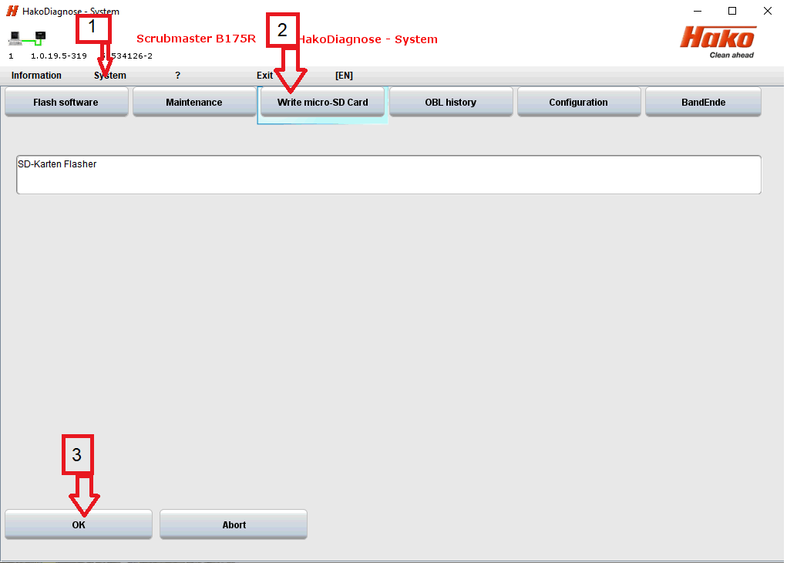  
  
  
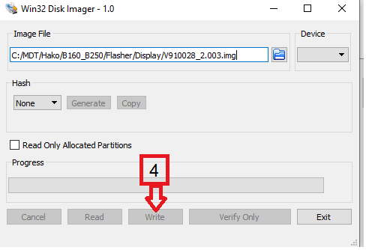  
switch off the machine.   
Insert the SD card to the dash board.   
Switch on the machine and confirm the new display software (Black screen with soft- and hardware information) by pressing the TPB.   
Then the new software will be initialized.   
After this is completed ( Loading screen) you have to switch off and then on the machine.   
  
Mit freundlichen Grüssen /  Sincerely  
  
Friedhelm Fechtner